|  |  |
| --- | --- |
|  | **Department of Computer Science**  **University of Management and Technology** |

**Assignment Description File**

|  |  |
| --- | --- |
| Course Name: | **Software Engineering** |
| Section: | V4 |
| Teacher: | **Fasiha Ashraf** |
| Student Name n ID | **Areesha Noor F2022266674**  **Abdullah Shafqat F2022266675** |
| Assignment No.: | **2** |
| Deadline: | FOLLOW LMS SUBMISSION DEADLINE |

**NOTE: PLAGIARIZED ASSIGNMENT EITHER FROM CLASSMATES OR INTERNET WILL BE MARKED STRAIGHT ZERO.NO ASSIGNMENT WILL BE ACCEPTED AFTER DEADLINE.ALWAYS MENTION SECTION ON ASSIGNMENT**

**FOLLOW THE TEMPLATE ATTACHED. Submit softcopy on LMS**

**Assignment Description:**

**Q1: Requirements (Functional & Non-Functional) (10 Marks)**

**Q2: List of Actors (10 Marks)**

#### Q3: Use Case List and Analysis (10 Marks)

#### Q4: System Use Case Diagram (10 Marks)

#### Q5: User Interface Design (Mock Screens & Analysis) (10 Marks)

# 1. Requirements analysis

## Requirements

The Dairy Farm Management System (DFMS) requirements are as follows:

**Functional Requirements:**

- Real-time animal health tracking and productivity monitoring.

- Automated record-keeping for milk production.

- Inventory management for feed and supplies.

- Sales and billing for dairy products.

- Analytical tools for farm productivity analysis.

**Non-Functional Requirements:**

- High reliability, scalability, and security.

- Detailed reports generation capability.

- System response within 3 seconds for essential tasks.

**Constraints:**

- Integration with external systems (e.g., Weather API, wearable health trackers).

- Accessible user interface for diverse stakeholders.

1.2 List of Actors

Actors identified for the DFMS:

#### 1. Farm Manager:

Oversees farm operations and uses the system for management.

**2. Veterinarian:**

Monitors animal health via system health records.

**3. Sales Manager:**

Manages sales and invoicing using the system.

**4. Farm Workers**:

Log daily tasks and feeding schedules in the system.

**5. Farm Owner:**

Tracks profitability and productivity through system-generated reports.

## 1.3 List of use cases

Use Cases for DFMS:  
**1. Record Animal Health:**

Logs health data for individual animals.

**2. Manage Milk Production:**

Tracks milk yields and schedules.

**3. Inventory Management:**

Updates feed and supplies stock levels.

**4. Sales and Billing:**

Generates invoices for dairy products sold.

**5. Generate Reports:**

Produces detailed operational and financial reports.

## 1.4 System use case diagram

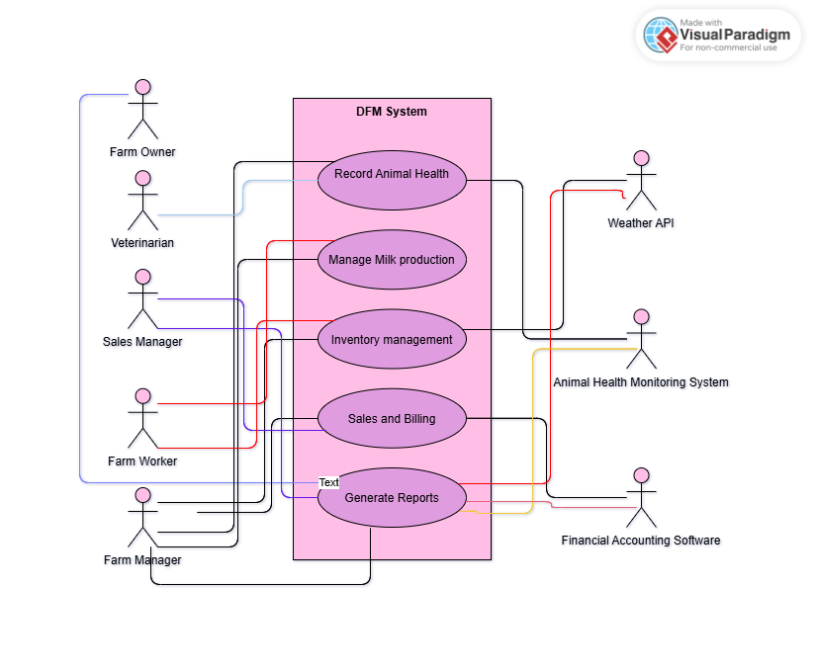

1.5 Extended use cases

Detailed descriptions of each use case are as follows:

**Use Case ID:**

UC-1

**Use Case Name:**

Record Animal Health

**Description:**

Allows veterinarians to log and review animal health data.

**Actors:**

Veterinarian, Farm Manager.

**Preconditions:**

Animal has wearable health tracker linked to the system.

**Postconditions:**

Health data logged and accessible for analysis.

**Normal Flow:**

1. Veterinarian selects an animal from the list.

2. System retrieves and displays the animal's current health data.

3. Veterinarian updates records as necessary.

**Alternative Flows:**

- Health tracker data unavailable: System prompts manual entry.

1.6 User interfaces (mock screens)

Initial mockup screens will include:

1. Animal Health Dashboard.

2. Milk Production Log.

3. Inventory Management Panel.

4. Sales Invoicing System.

5. Analytics and Reports Dashboard.

